**2024.07.31**

**Engineering Question of PN:NEO-M9N_MODULE**

**Question 1:**  The PCB board fabrication information is not specified.

**Suggestion :** Follow below information to make this board, unless otherwise specified.

Material: FR-4 TG≥130.

Finished board thickness shall be 1.6mm+/-10%.

Finished copper thickness shall be 35um on both outer layers and 35um base copper in inner layers.

Matte black color of solder mask.

White color of silkscreen

Surface finish shall be HASL-lead free.

**Reply:Yes**

**Question 2:** See below IMG, there are designed with soldmask opening on some via holes. It will be easy cause shorten in solder process.Can we delete the soldmask opening of via holes and covered with soldmask ink？

**Suggestion 1:** Allow to delete the soldmask opening of all Dia0.2mm and Dia0.25mm and covered with sodlamsk ink.

**Suggestion 2:** Follow the original gerber files.

**Reply: Suggestion 1**

**PIC2:**

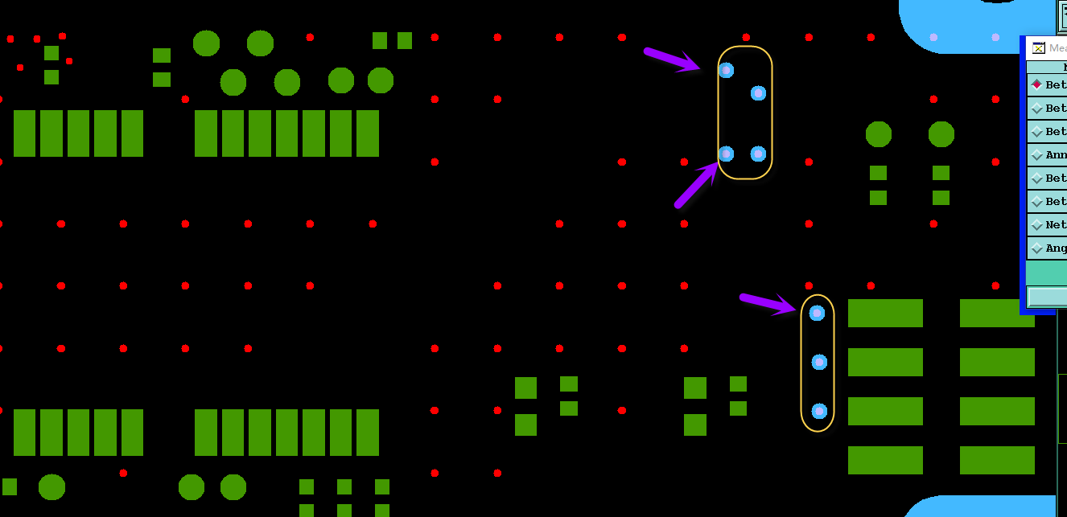

**Question 3:** See below IMG,there are miss four holes in drill files.

**Suggestion 1:** We will refer to the circle of GM1 layer to build, the drill holes size as 3.1mm to build.

**Suggestion 2:** Or please indicated.

**Reply: Suggestion 1**

**PIC3:**

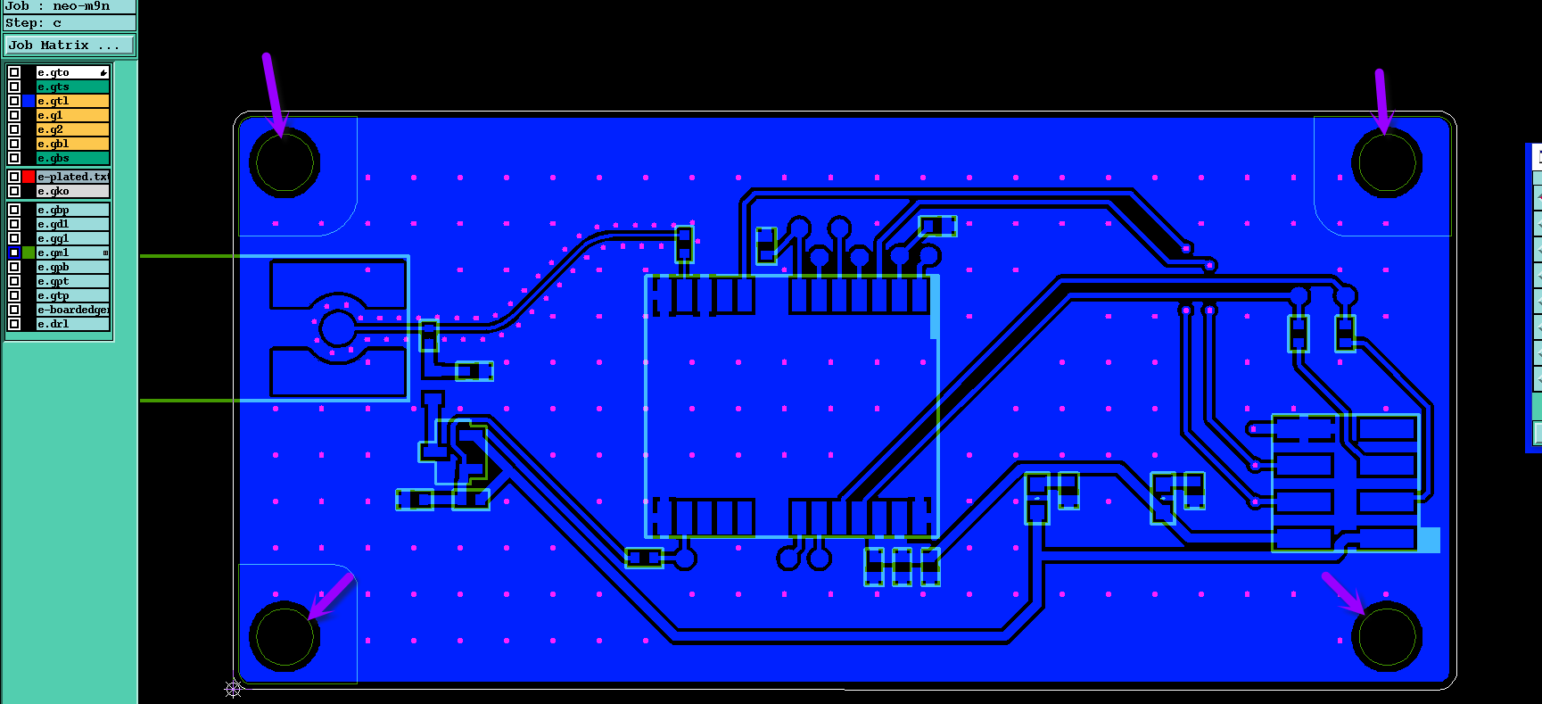

**Question 4** See below IMG, to traceability, we will add datecode (wwyy) on the top silkscreen layer, please confirm

**Suggestion:** Please confirm

**Reply: Yes**

**PIC4:**

